**Why AWS?**

**Youtube:**

**Youtube:**

**Youtube:**

The AWS machine learning mission is to put machine learning in the hands of every developer.

* AWS offers the broadest and deepest set of artificial intelligence (AI) and machine learning (ML) services with unmatched flexibility.
* You can accelerate your adoption of machine learning with AWS SageMaker. Models that previously took months to build and required specialized expertise can now be built in weeks or even days.
* AWS offers the most comprehensive cloud offering optimized for machine learning.
* More machine learning happens at AWS than anywhere else.

**AWS Machine Learning offerings**

**AWS AI services**

By using AWS pre-trained AI services, you can apply ready-made intelligence to a wide range of applications such as personalized recommendations, modernizing your contact center, improving safety and security, and increasing customer engagement.

**Industry-specific solutions**

With no knowledge in machine learning needed, add intelligence to a wide range of applications in different industries including healthcare and manufacturing.

**AWS Machine Learning services**

With AWS, you can build, train, and deploy your models fast. **Amazon SageMaker** is a fully managed service that removes complexity from ML workflows so every developer and data scientist can deploy machine learning for a wide range of use cases.

**ML infrastructure and frameworks**

AWS Workflow services make it easier for you to manage and scale your underlying ML infrastructure.

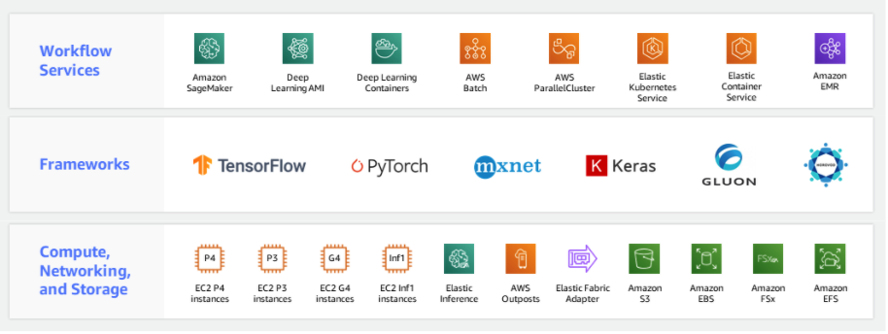

ML infrastructure and frameworks

**Getting started**

In addition to educational resources such as AWS Training and Certification, AWS has created a portfolio of educational devices to help put new machine learning techniques into the hands of developers in unique and fun ways, with **AWS DeepLens**, **AWS DeepRacer**, and **AWS DeepComposer**.

* **AWS DeepLens:** A deep learning–enabled **video camera**
* **AWS DeepRacer:** An **autonomous race car** designed to test reinforcement learning models by racing on a physical track
* **AWS DeepComposer:** A **composing device** powered by generative AI that creates a melody that transforms into a completely original song
* **AWS ML Training and Certification:** Curriculum used to train Amazon developers

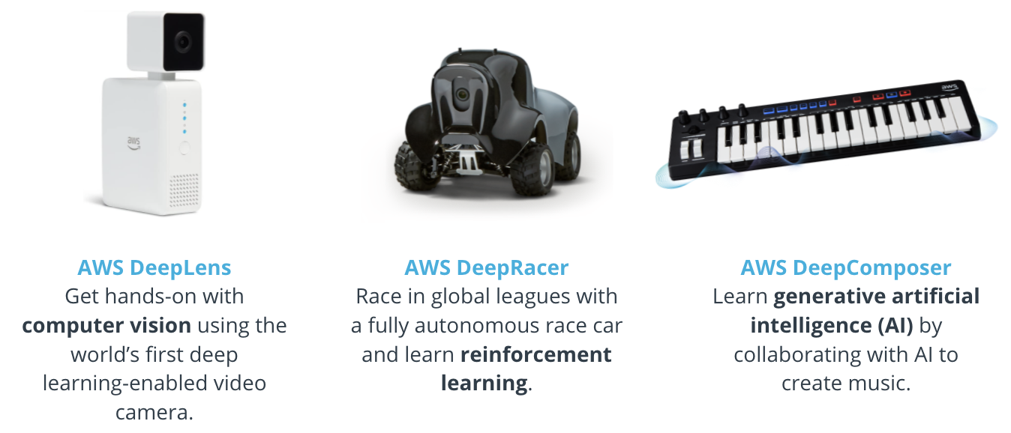

AWS educational devices

**Additional Reading**

* To learn more about AWS AI Services, see [Explore AWS AI services](https://aws.amazon.com/machine-learning/ai-services/?utm_source=Udacity&utm_medium=Webpage&utm_campaign=Udacity%20AWS%20ML%20Foundations%20Course).
* To learn more about AWS ML Training and Certification offerings, see [Training and Certification](https://aws.amazon.com/training/?trk=ps_a134p000006vdeTAAQ&trkCampaign=GLBL-FY21-TrainCert-Combined_PaidSearch&sc_channel=PS&sc_campaign=FY21-TrainCert-Combined_PaidSearch&sc_publisher=Google&sc_category=Training%20and%20Certification&sc_country=CA&sc_geo=NAMER&sc_outcome=acq&sc_detail=aws%20training%20and%20certification&sc_content=Generic_exact&sc_matchtype=e&sc_segment=502617786875&sc_medium=TC-P%7CPS-GO%7CBrand%7CDesktop%7CAW%7CTraining%20and%20Certification%7CCombo%7CCA%7CEN%7CText%7Cxx%7CSEM%7CPMO20-00038&s_kwcid=AL!4422!3!502617786875!e!!g!!aws%20training%20and%20certification&s_kwcid=AL!4422!3!502617786875!e!!g!!aws%20training%20and%20certification&ef_id=Cj0KCQjw6-SDBhCMARIsAGbI7UjdXMChuEmUUD2-j8XnYXVklQdsT4KPqYV3lAxL3ww_fQUvs9fGmRoaAkdpEALw_wcB%3AG%3As&utm_source=Udacity&utm_medium=Webpage&utm_campaign=Udacity%20AWS%20ML%20Foundations%20Course).